FEM HW5

2.

a) Read the code and draw a detailed flowchart of it.

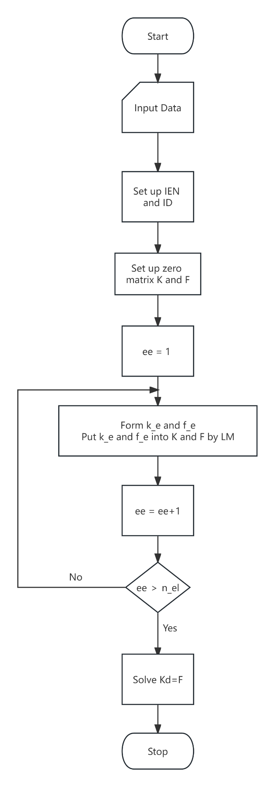

**b)** Plot the relative errors against the mesh size in the log-log plot (i.e., plot log(error) against log(h)). Determine the slope of the curves.

**c)** Enable the code for higher-order elements using quadratic and cubic elements. Modify the code. Repeat the calculation of the errors using the two higher order elements.

|  |  |
| --- | --- |
|  |  |
|  |  |
|  |  |

**d)** The usage of the command gmres in Matlab. Set restart=maxit=10000. Set the value of tol to be 1e-2, 1e-4, and 1e-6, and compare the solutions against those obtained by the direct method (i.e. LU factorization). Give your comments.

The results with different tol values are all equal.

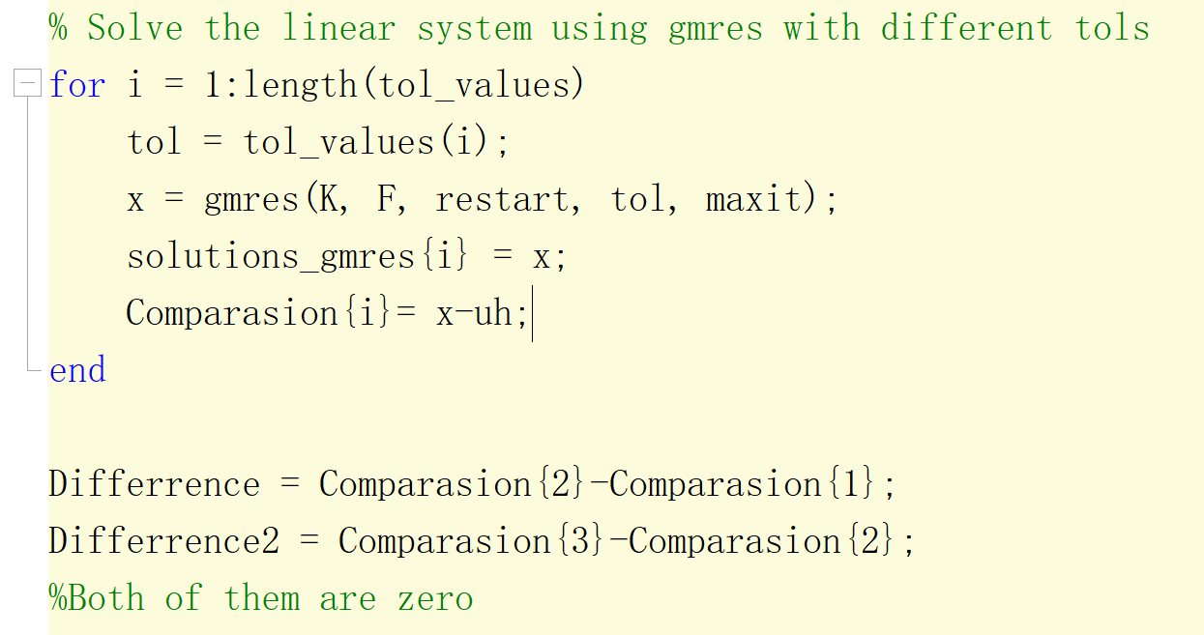

**e)** Run the code with the element of degree 3 (i.e. cubic element). Experiment the code with 1,2,3,4,5,6 quadrature points, respectively. Report your observations and make comments.

The results with 1 and 2 quadrature points have “The matrix is close to a singular value, or is incorrectly scaled. The results may not be accurate.”, the other three test cases obtain the close results.

